- Login https://mc03.manuscriptcentral.com/ieee-jas
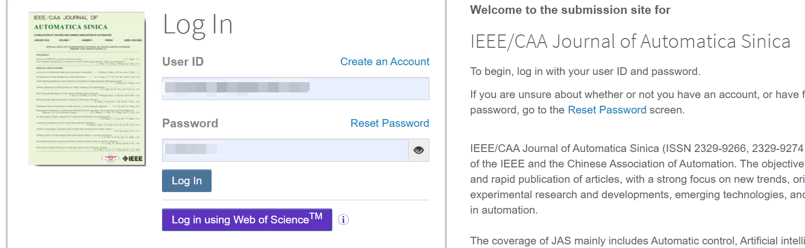
- In right up concern, Go to Account Email/Name page
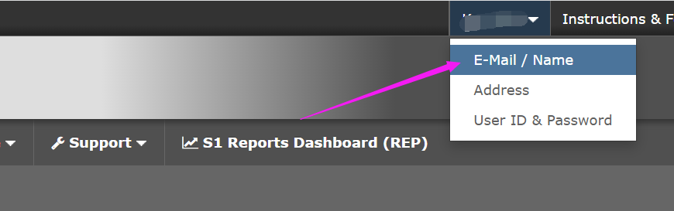
- Associate your Existing ORCID or Create an ORCID if you do not have
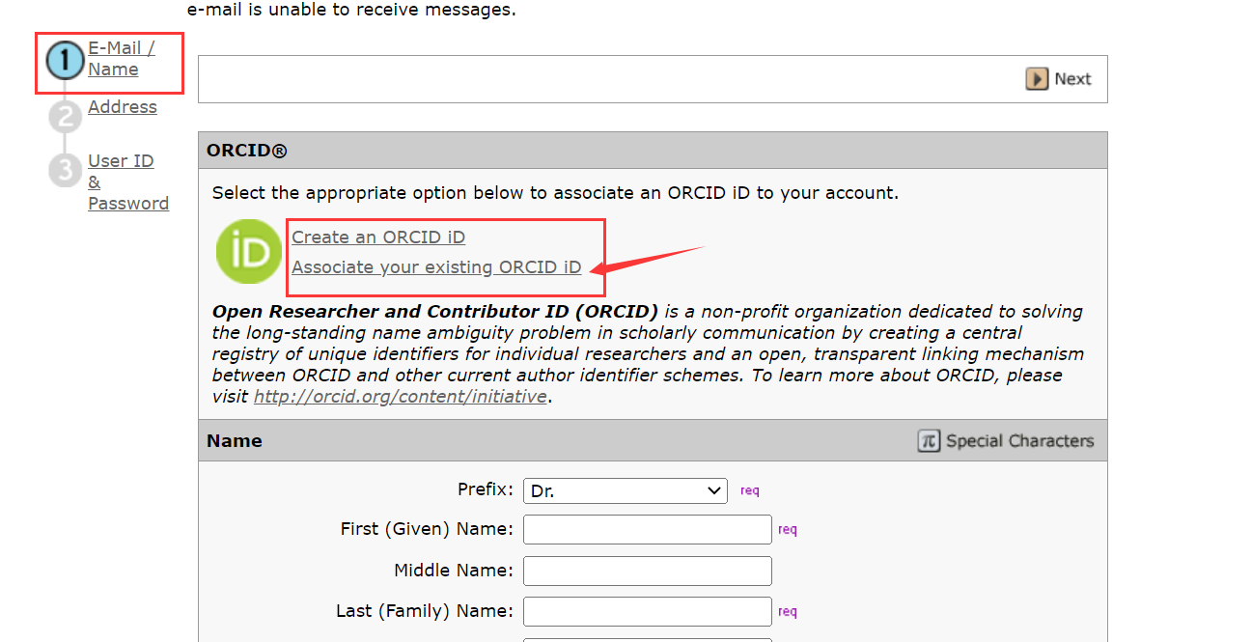

- Sign in your ORCID credential
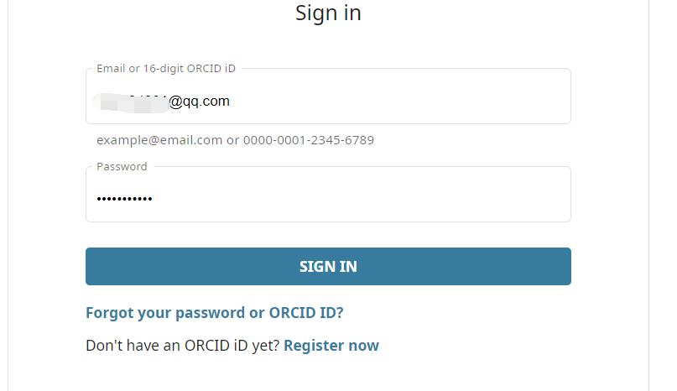
- Click “Authorize Access”
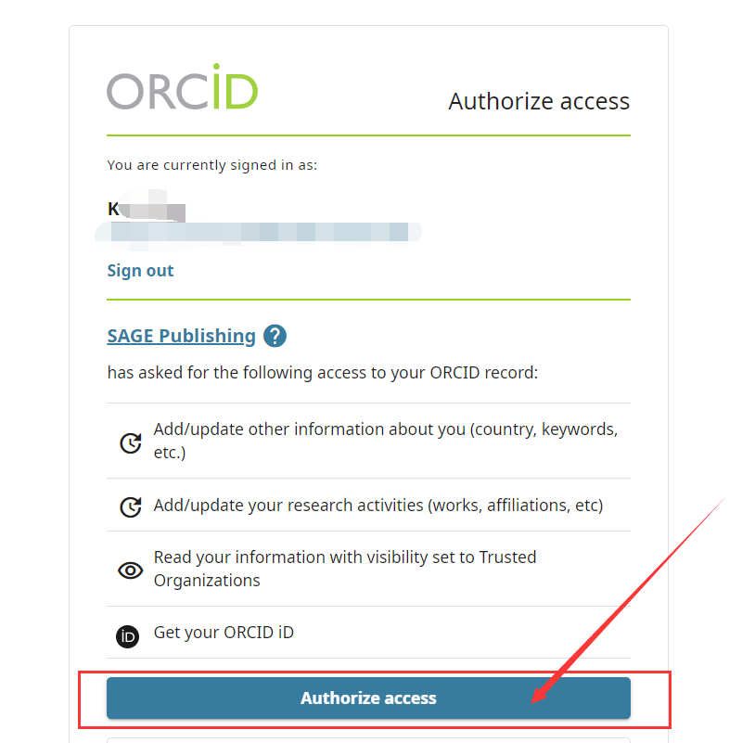
- Completed ORCID linking
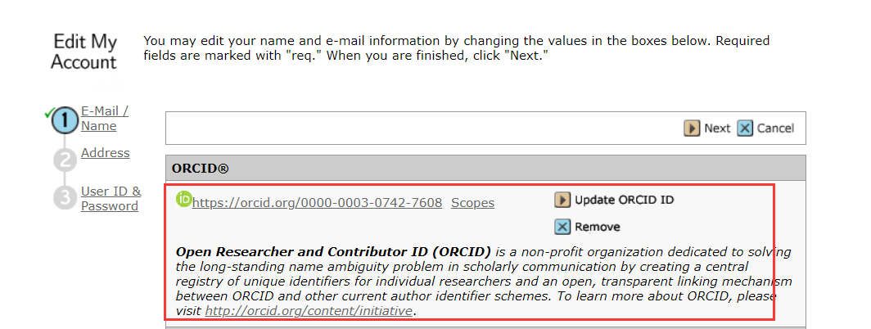
- Save and exit the page

